**Assignment-2**

**Course: Cybersecurity and Ethical Hacking**

**Name: Mohith Kalekar**

**Register No: 20BLC1082**

**Task 1:**

**1. Create a directory called "my_directory".**

**2. Navigate into the "my_directory".**

**3. Create an empty file called "my_file.txt".**

**4. List all the files and directories in the current directory.**

**5. Rename "my_file.txt" to "new_file.txt".**

**6. Display the content of "new_file.txt" using a pager tool of your choice.**

**7. Append the text "Hello, World!" to "new_file.txt".**

**8. Create a new directory called "backup" within "my_directory".**

**9. Move "new_file.txt" to the "backup" directory.**

**10. Verify that "new_file.txt" is now located in the "backup" directory.**

**11. Delete the "backup" directory and all its contents.**

**Output:**

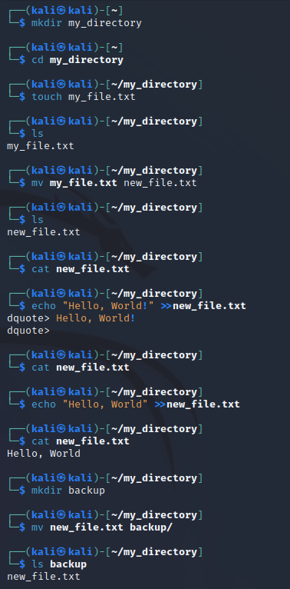



**Task 2:**

**● Create a new file called "my_script.sh".**

**● Edit "my_script.sh" using a text editor of your choice and add the following lines:**

**bash**

**#!/bin/bash**

**echo "Welcome to my script!"**

**echo "Today's date is $(date)."**

**Save and exit the file.**

**Output:**

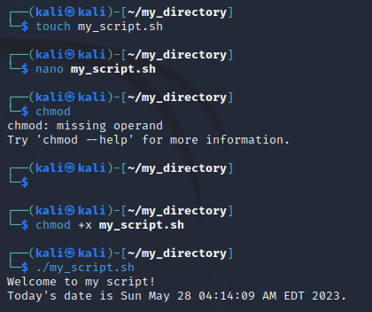

**Task 3:**

**● List all the processes running on your system using the "ps" command.**

**● Use the "grep" command to filter the processes list and display only the processes with**

**"bash" in their name.**

**● Use the "wc" command to count the number of lines in the filtered output.** 